Mandatory Assignment

**Table of content**

1 From Boolean expression to truth table 1

1.1 Fill out the truth table from the following Boolean expression: 1

1.2 Fill out the truth table from the following Boolean expression: 1

1.3 Fill out the truth table from the following Boolean expression: 2

1.4 Fill out the truth table from the following Boolean expression: 2

1.5 Write down the truthtable from the following Boolean expression. 3

2 From truth table to Boolean expression 3

2.1 Write down the Boolean expression described by the truthtable and simplify it as much as possible. 3

2.2 Write down the Boolean expression described by the truthtable and simplify it as much as possible. 4

2.3 Write down the Boolean expression described by the truthtable and simplify it as much as possible. 5

2.4 Write down the Boolean expression described by the truthtable and simplify it as much as possible. 6

2.5 Write down the Boolean expression described by the truthtable and simplify it as much as possible. 7

3 Boolean expression to circuit. 8

3.1 Draw the logic circuit described by the following Boolean expression 8

3.2 Draw the logic circuit described by the following Boolean expression 8

3.3 Draw the logic circuit described by the following Boolean expression 9

3.4 Draw the logic circuit described by the following Boolean expression 9

4 From circuit to Boolean expression 10

4.1 Write down the Boolean expression derived from the logical circuit below: 10

4.2 Write down the Boolean expression derived from the logical circuit below: 11

5 From circuit to truth table 11

5.1 Write down the truthtable from the following circuit: 11

5.2 Write down the truthtable from the following circuit: 12

5.3 Write down the truthtable from the following circuit: 13

5.4 Write down the truthtable from the following circuit: 14

5.5 Write down the truthtable from the following circuit: 15

# From Boolean expression to truth table

## Fill out the truth table from the following Boolean expression:

$$Out=A\overline{B} \overline{C}+BC$$

|  |  |  |  |
| --- | --- | --- | --- |
| **A** | **B** | **C** | **Out** |
| 0 | 0 | 0 | 0 |
| 0 | 0 | 1 | 0 |
| 0 | 1 | 0 | 0 |
| 0 | 1 | 1 | 1 |
| 1 | 0 | 0 | 1 |
| 1 | 0 | 1 | 0 |
| 1 | 1 | 0 | 0 |
| 1 | 1 | 1 | 1 |



## Fill out the truth table from the following Boolean expression:

$$Out=\overline{B}$$

|  |  |  |  |
| --- | --- | --- | --- |
| **A** | **B** | **C** | **Out** |
| 0 | 0 | 0 | 1 |
| 0 | 0 | 1 | 1 |
| 0 | 1 | 0 | 0 |
| 0 | 1 | 1 | 0 |
| 1 | 0 | 0 | 1 |
| 1 | 0 | 1 | 1 |
| 1 | 1 | 0 | 0 |
| 1 | 1 | 1 | 0 |

## Fill out the truth table from the following Boolean expression:

$$Out=1$$

|  |  |  |  |
| --- | --- | --- | --- |
| **A** | **B** | **C** | **Out** |
| 0 | 0 | 0 | 1 |
| 0 | 0 | 1 | 1 |
| 0 | 1 | 0 | 1 |
| 0 | 1 | 1 | 1 |
| 1 | 0 | 0 | 1 |
| 1 | 0 | 1 | 1 |
| 1 | 1 | 0 | 1 |
| 1 | 1 | 1 | 1 |

## Fill out the truth table from the following Boolean expression:

$$Out=C(A+B)$$

|  |  |  |  |
| --- | --- | --- | --- |
| **A** | **B** | **C** | **Out** |
| 0 | 0 | 0 | 0 |
| 0 | 0 | 1 | 0 |
| 0 | 1 | 0 | 0 |
| 0 | 1 | 1 | 1 |
| 1 | 0 | 0 | 0 |
| 1 | 0 | 1 | 1 |
| 1 | 1 | 0 | 0 |
| 1 | 1 | 1 | 1 |

## Write down the truthtable from the following Boolean expression.

$$Out=B(A+C)+\overline{B} \overline{C} \overline{A}$$

Solution

|  |  |  |  |
| --- | --- | --- | --- |
| **A** | **B** | **C** | **Out** |
| 0 | 0 | 0 | 1 |
| 0 | 0 | 1 | 0 |
| 0 | 1 | 0 | 0 |
| 0 | 1 | 1 | 1 |
| 1 | 0 | 0 | 0 |
| 1 | 0 | 1 | 0 |
| 1 | 1 | 0 | 1 |
| 1 | 1 | 1 | 1 |

# From truth table to Boolean expression

## Write down the Boolean expression described by the truthtable and simplify it as much as possible.

|  |  |  |  |
| --- | --- | --- | --- |
| **A** | **B** | **C** | **Out** |
| 0 | 0 | 0 | 0 |
| 0 | 0 | 1 | 0 |
| 0 | 1 | 0 | 0 |
| 0 | 1 | 1 | 1 |
| 1 | 0 | 0 | 0 |
| 1 | 0 | 1 | 1 |
| 1 | 1 | 0 | 0 |
| 1 | 1 | 1 | 1 |

**SOLUTION**

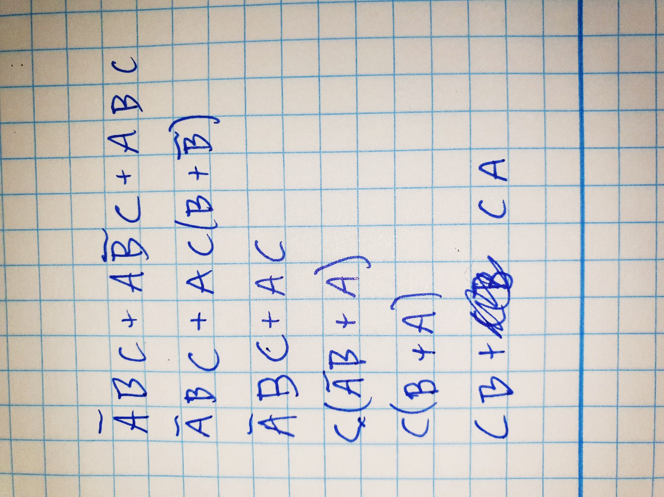

## Write down the Boolean expression described by the truthtable and simplify it as much as possible.

|  |  |  |  |
| --- | --- | --- | --- |
| **A** | **B** | **C** | **Out** |
| 0 | 0 | 0 | 1 |
| 0 | 0 | 1 | 0 |
| 0 | 1 | 0 | 0 |
| 0 | 1 | 1 | 1 |
| 1 | 0 | 0 | 1 |
| 1 | 0 | 1 | 0 |
| 1 | 1 | 0 | 0 |
| 1 | 1 | 1 | 1 |

**SOLUTION**

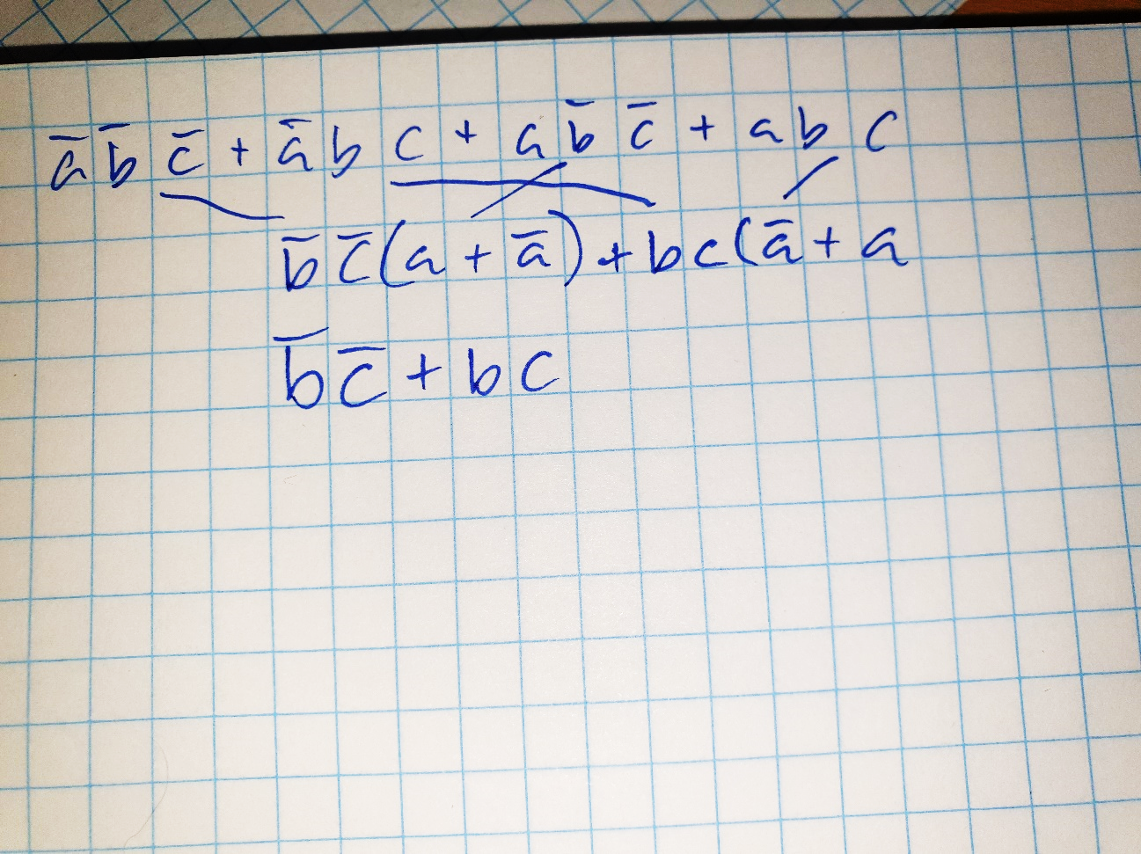

## Write down the Boolean expression described by the truthtable and simplify it as much as possible.

|  |  |  |  |
| --- | --- | --- | --- |
| **A** | **B** | **C** | **Out** |
| 0 | 0 | 0 | 0 |
| 0 | 0 | 1 | 1 |
| 0 | 1 | 0 | 1 |
| 0 | 1 | 1 | 0 |
| 1 | 0 | 0 | 0 |
| 1 | 0 | 1 | 0 |
| 1 | 1 | 0 | 1 |
| 1 | 1 | 1 | 0 |

**Solution**

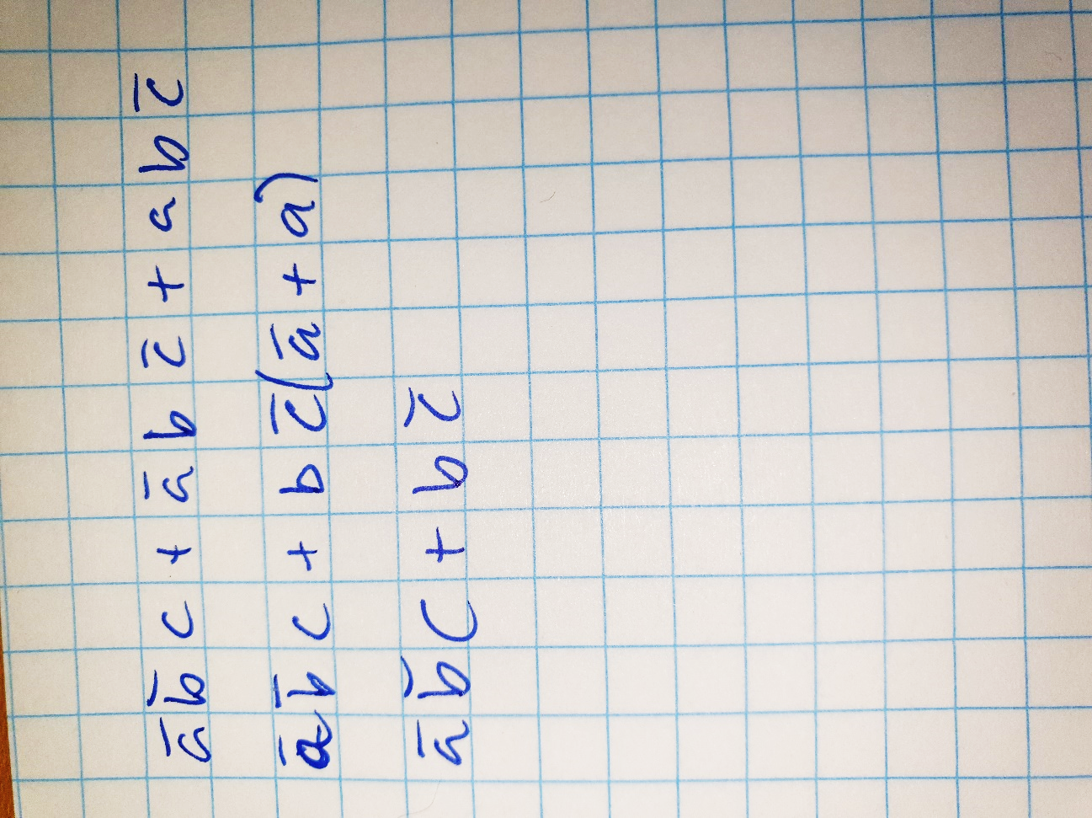

## Write down the Boolean expression described by the truthtable and simplify it as much as possible.

|  |  |  |  |
| --- | --- | --- | --- |
| **A** | **B** | **C** | **Out** |
| 0 | 0 | 0 | 1 |
| 0 | 0 | 1 | 1 |
| 0 | 1 | 0 | 0 |
| 0 | 1 | 1 | 0 |
| 1 | 0 | 0 | 1 |
| 1 | 0 | 1 | 1 |
| 1 | 1 | 0 | 1 |
| 1 | 1 | 1 | 0 |

**Solution**

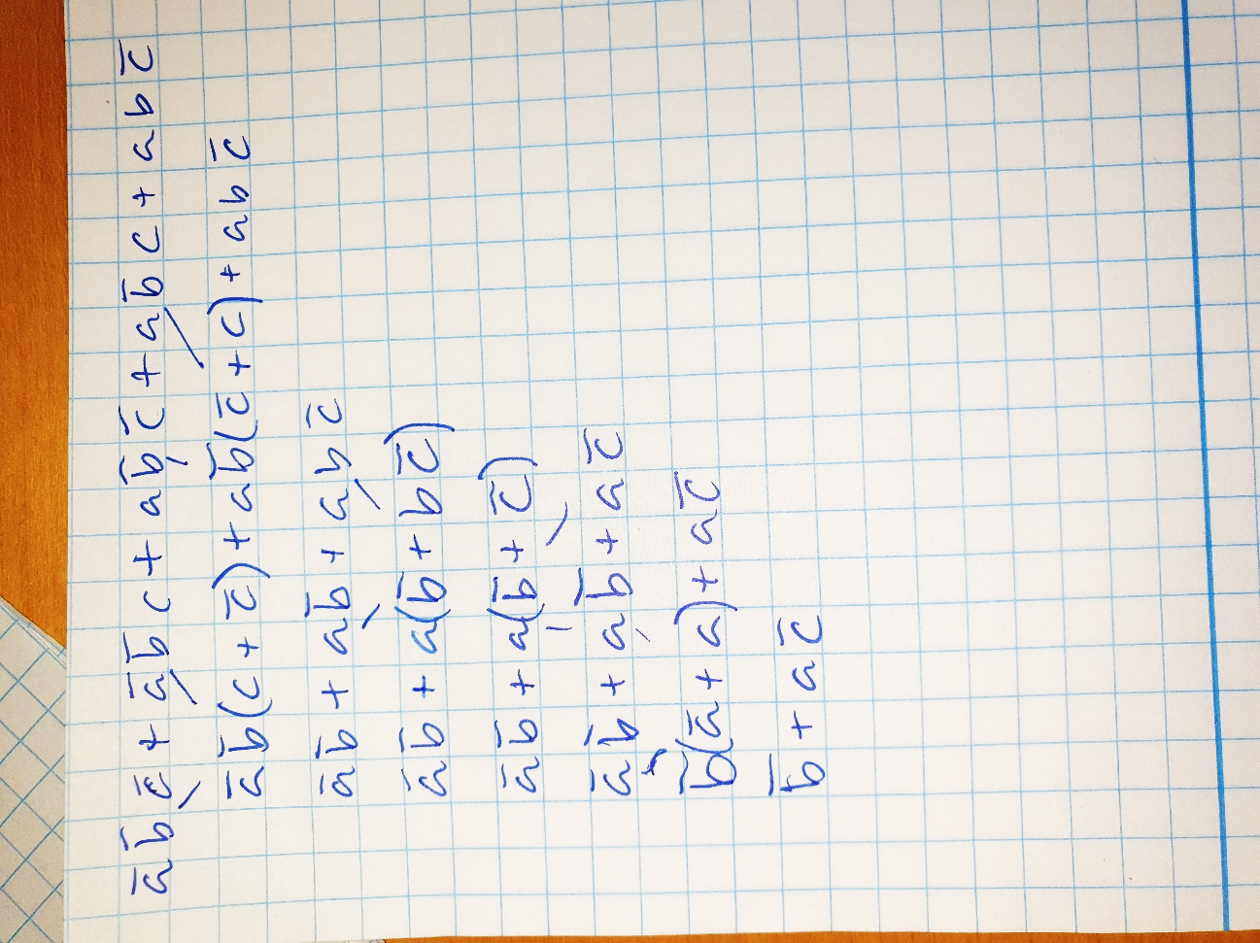

## Write down the Boolean expression described by the truthtable and simplify it as much as possible.

|  |  |  |  |
| --- | --- | --- | --- |
| **A** | **B** | **C** | **Out** |
| 0 | 0 | 0 | 1 |
| 0 | 0 | 1 | 1 |
| 0 | 1 | 0 | 1 |
| 0 | 1 | 1 | 1 |
| 1 | 0 | 0 | 1 |
| 1 | 0 | 1 | 1 |
| 1 | 1 | 0 | 1 |
| 1 | 1 | 1 | 0 |

**Solution**

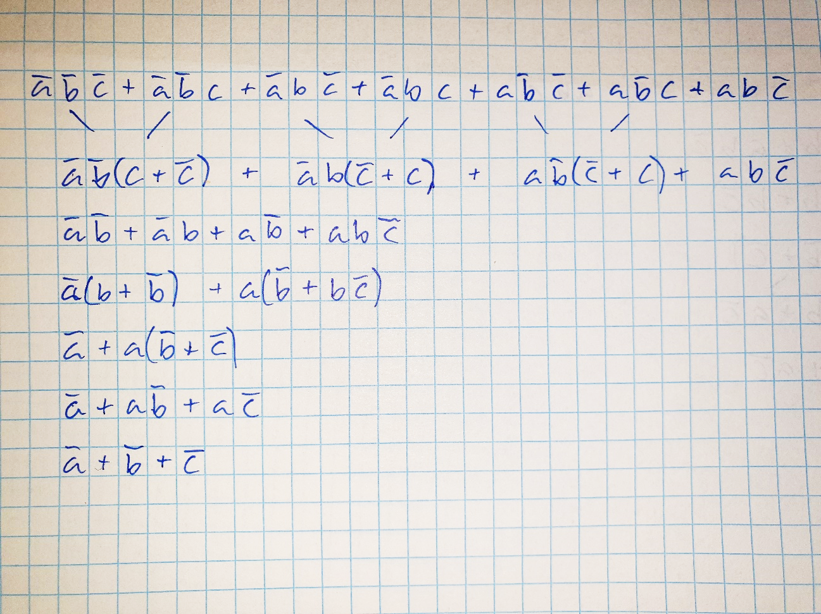

# Boolean expression to circuit.

## Draw the logic circuit described by the following Boolean expression

$$Out=A+\overline{B}$$

Solution

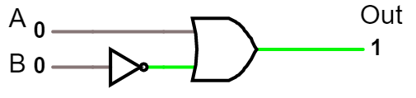

## Draw the logic circuit described by the following Boolean expression

$$Out=CA+\overline{B}$$

Solution

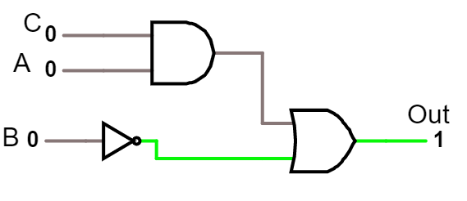

## Draw the logic circuit described by the following Boolean expression

$$Out=A\overline{B}C+\overline{A}BC$$

Solution

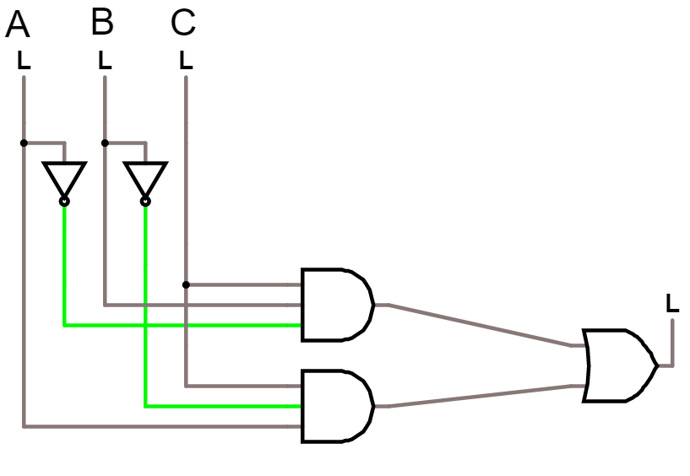

## Draw the logic circuit described by the following Boolean expression

$$Out=A(\overline{B}+\overline{A} C)$$

Solution

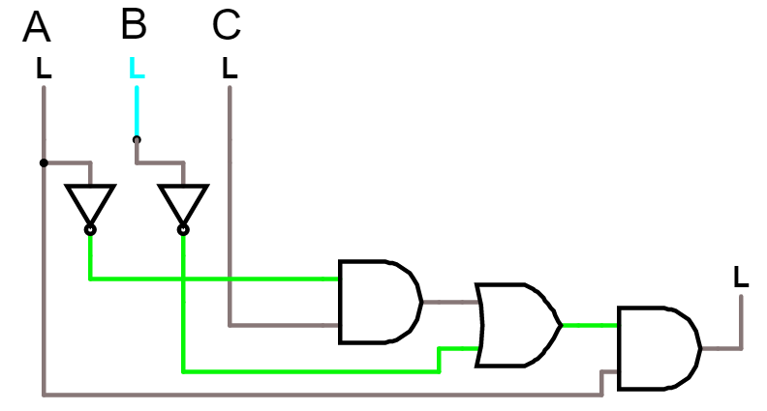

# From circuit to Boolean expression

## Write down the Boolean expression derived from the logical circuit below:

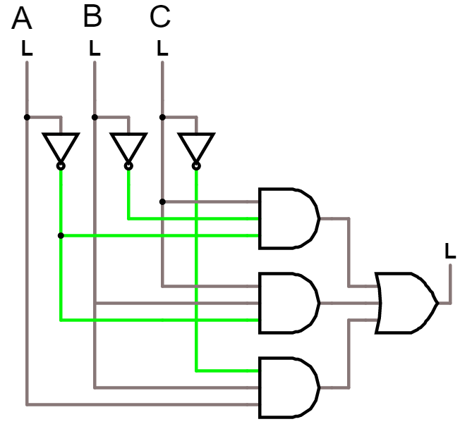

Solution

$$\overline{A} \overline{B}C+\overline{A}BC+AB\overline{C}$$

## Write down the Boolean expression derived from the logical circuit below:

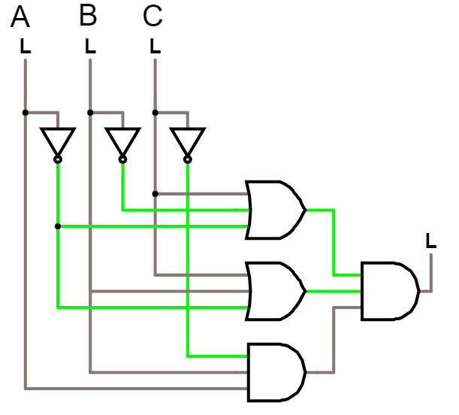

Solution

$$(\overline{A}+\overline{B}+C)(\overline{A}+B+C)(AB\overline{C} )$$

# From circuit to truth table

## Write down the truthtable from the following circuit:

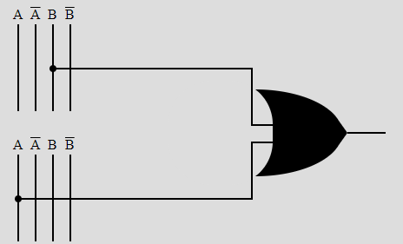

|  |  |  |
| --- | --- | --- |
| A | B | Out |
| 0 | **0** |  |
| 0 | **1** |  |
| 1 | **0** |  |
| 1 | **1** |  |

**Solution**

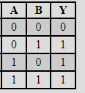

## Write down the truthtable from the following circuit:

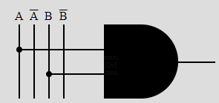

**Solution**

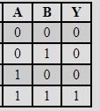

## Write down the truthtable from the following circuit:

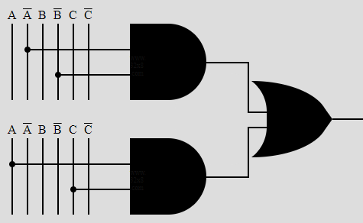

|  |  |  |  |
| --- | --- | --- | --- |
| **A** | **B** | **C** | **Out** |
| 0 | 0 | 0 |  |
| 0 | 0 | 1 |  |
| 0 | 1 | 0 |  |
| 0 | 1 | 1 |  |
| 1 | 0 | 0 |  |
| 1 | 0 | 1 |  |
| 1 | 1 | 0 |  |
| 1 | 1 | 1 |  |

**Solution**

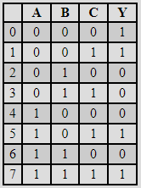

## Write down the truthtable from the following circuit:

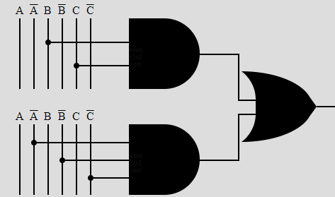

Solution

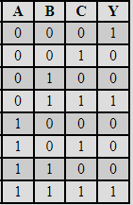

## Write down the truthtable from the following circuit:

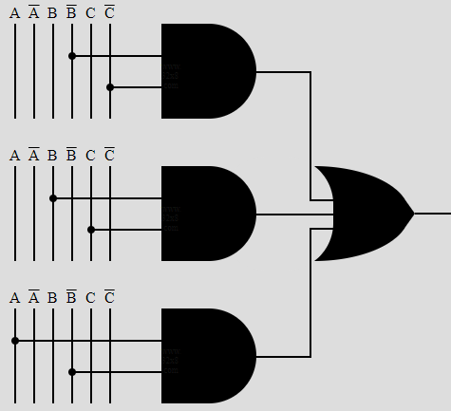

Solution

